ANGER
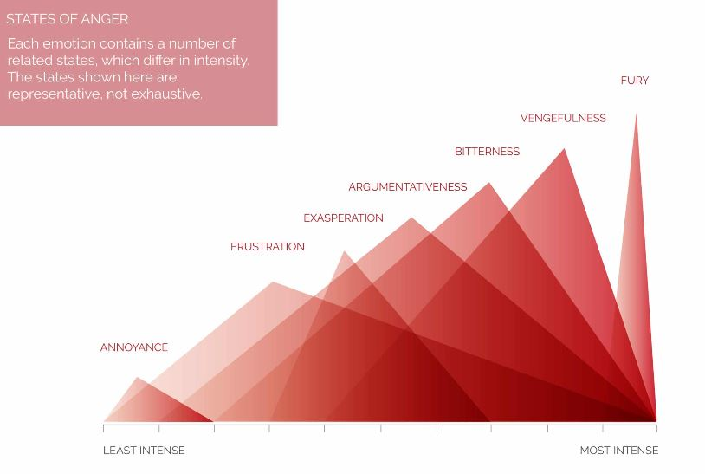
Annoyance | 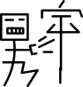
Frustration | 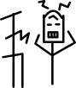
Exasperation | 
Argumentativeness | 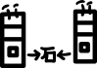
bitterness | 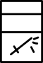
Vengefulness | 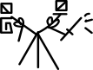
Fury | 

