BAR
 | 
Rod
Pipe | 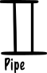
Wood | 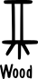
Staff
cylinder
Flute
Stick
Branch
Stem
Stalk
Pedicle
Peduncle
stalk

