Board

NOUNS
teacher | 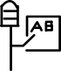 | Sanskrit: (Vedic) अदिक्षि (adikṣi),
, tablet , plate , , notepad , blackboard , whiteboard , plank , slab , phone , monitor , led , road signboard , switchboard ,

VERBS
ENGLISH |  |  | MANTRAKSHAR | ETYMOLOGY
demonstrate | demonstrare | epideiknýo | 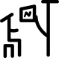 | dē- (“concerning”) +‎ mōnstrō (“I show”)
display | ostentus | apeikónisi | 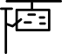 | from Latin dis- (“apart”) + plicāre (“to fold”)
draw | haurire | schediázo | 
dream | somnium | óneiro | 
educate | educare | ekpaidéfsei | 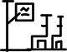 | , from e (“out”) + ducere (“to lead, draw”). , Equivalent to ex- +‎ dūcō.
explain | explicare | exigó | 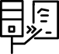 | from ex- (“out”) + planō (“I flatten, make level”)
illustrate | illustrare | eikonografó |  | From in- +‎ lūstrō (“to purify via sacrifice; to illuminate”).
instruct | instrue | entolí | 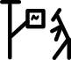 | Equivalent to in- (“in, at, on”) +‎ struō (“pile , arrange; construct”)

Preposition
Proximal | Proximal | Engýtatos | 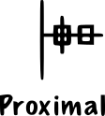
Distal | Distal | ápo | 

