ONTOLOGY
- Ontological categories
- Ontology of symbols
- MATERIALISTIC ONTOLOGIES OR CLASS
  - Ontology of universe
  - Ontology of life

TABLE
make | 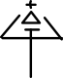
type | 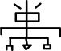
classify | 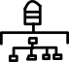
sort | 

