ROOTS OF QUANTITY
English | Greek Root | Latin Root
double | diplo- | dupli- | 
equal | iso- | equi- | 
few | oligo- | pauci- | 
half | hemi- | semi- | 
many, much | poly- | multi- | 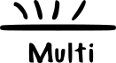
twice | dis- | bis-
with |  |  | 
without |  |  | 

